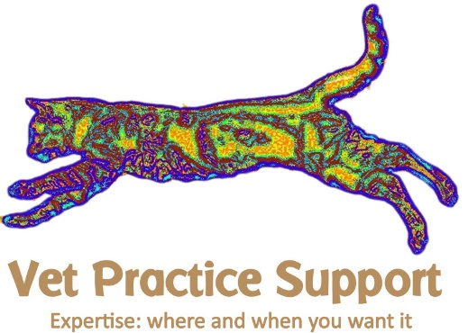
Consent for procedures
Date: Click here to enter a date.
Owner’s name: Click here to enter text.
Address: Click here to enter text.

Patient name: Click here to enter text.
Patient species: Click here to enter text.
Patient breed: Click here to enter text.
Patient colour: Click here to enter text.
Details of the Procedure: Click here to enter text.

Including (tick as appropriate):
Ultrasound scan ☐
Sedation ☐
General anaesthesia ☐
Clipping of hair ☐
Blood sampling ☐
Urine sampling by needle󠇪 ☐
Needle biopsy ☐
Use of unlicensed medicines ☐ details: Click here to enter text.
I hereby give permission for the procedures detailed on this form together with any other procedures which may prove necessary in an emergency.
- The nature of these procedures and of other such procedures as might prove necessary has been explained to me.
- I understand that there are some risks involved in all procedures.
- In the event that the veterinary surgeon is unable to contact me on the numbers provided, I understand the veterinary surgeon will act in the best interests of my animal.

Signature: Click here to enter text.

Date: Click here to enter a date.

